Download address：<https://gitee.com/Crazy-code/PHPCrazy>

testing environment：phpstudy

C:\phpstudy_pro\WWW\PHPCrazy-master\PHPCrazy-master\admin\admin#users.php

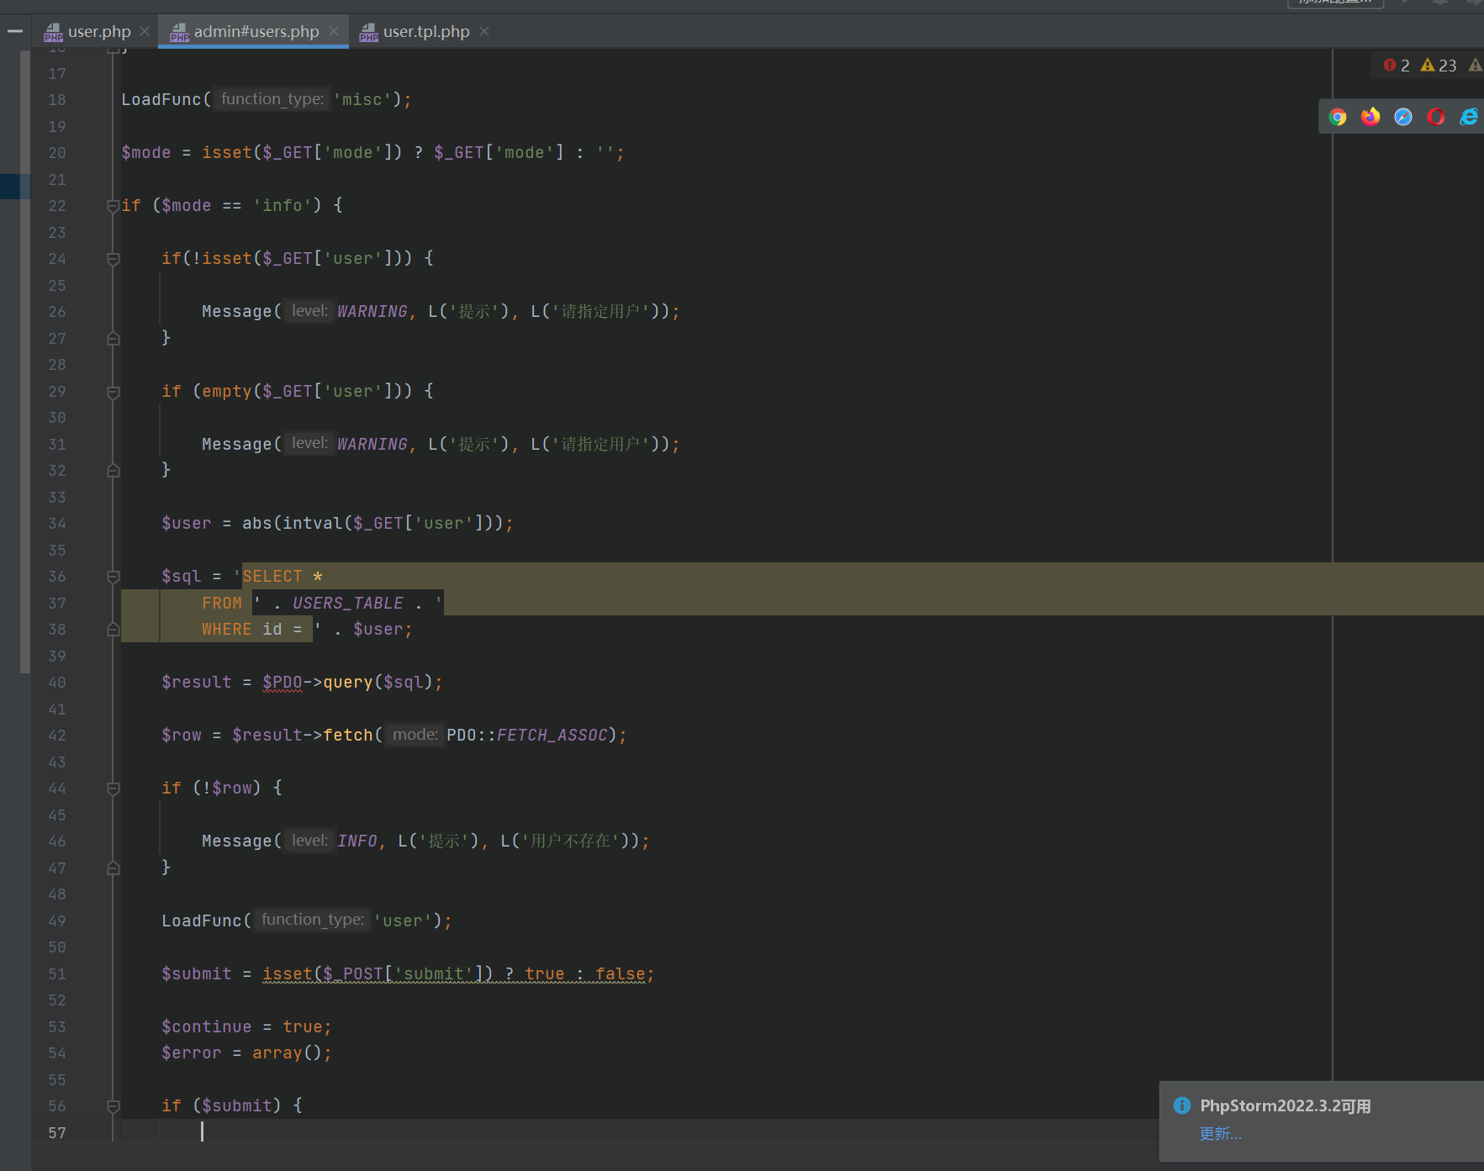

The parameters entered by the user are not filtered, and are parsed into javascript code for execution, resulting in

